Makale Başlığı (Arial,14)
Adı Soyadı¹, Adı Soyadı², Adı Soyadı³ (Arial, 12)
Üniversitesi, Bölüm, Şehir, Ülke, (Calibri, italic, 10)
email : xxx@xxxx (Calibri, italic, 10)

ABSTRACT
The abstract should be written in MS Word format in single-spaced in 12 point Times New Roman. Please, keep within the limit of 150-300 words, do not make reference citations in the abstract and do not add any graph or figure in this part. The aim and/or objectives of the study should be stated here. Please, indicate the author making the presentation with an asterisk (*).
Please, follow the guidelines in order to facilitate the editors to produce the proceedings on time. The incorrect formats may result in your abstract being returned to you.

Keywords: Abstract; BOD; COD; Example keywords; Layout (up to 5 keywords arranged in alphabetical order).

- MAJOR HEADINGS
Major headings are typed bold in 12pt upper case (capital letters), with two lines space above and below. Text should be justified (extend to the right-hand margin) and be typed to fill the full depth of the text area. Please, use a single-spaced 12pt Times New Roman typeface. Do not indent the text paragraphs. Official language of the conference is English.

2. MATERIAL AND METHODS
Outline the materials and methods used in your study here.

  - Minor headings
Minor headings are in 12pt bold type, not indented, with one line of space above and below. Do not number headings.
Sub-headings. Sub-headings are typed in 12pt italic (not underlined), not indented, with the paragraph running on after a full stop; there is one line of space above.

New paragraphs are not indented, but are preceded by a line of space. Also please avoid using footnotes or splitting tables over two (or more) pages.
3. RESULTS AND DISCUSSION
Describe and discuss the results here and/or the finding/contents of your study.

Table 1. This is an example of table layout. It shows the dimensions of the text area. Note that a minimum number of horizontal rules and (usually) no vertical rules are used.
 | Text area | A4 paper |  |  | US (Imperial) paper
 | (mm) | (mm) | (in) |  | (mm) | (in)
Depth | 250 | 297 | 11.69 |  | 279.32 | 11.0
Top/bottom margin | - | 25 | 1.0 |  | 15 | 0.6
Width | 170 | 210 | 8.27 |  | 215.84 | 8.5
Left/right margin | - | 20 | 0.8 |  | 23 | 0.9

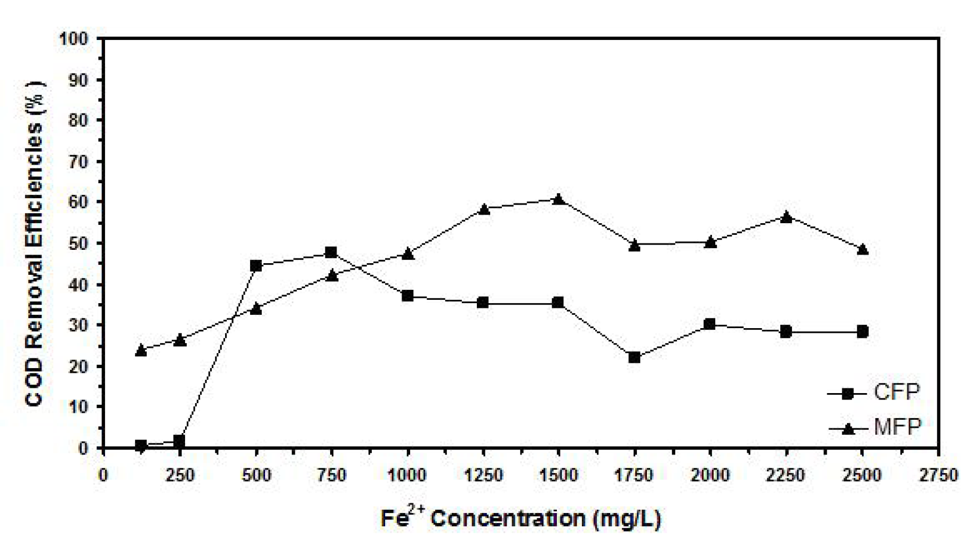
Figure 1. This is an example layout for the figures. It shows the dimensions of the figure/graph.

4. CONCLUSION
Present your conclusions here. If you use any references, these should be numbered in the order in which they appear in the text. In the text, enclose reference numbers in square brackets, e.g. [1], [1, 2], [1-3], … etc. That means that references should not be listed in alphabetical order. Journal articles as depicted in the example below should conform to the standard Vancouver style of punctuation, and abbreviations.

Finally, please ensure that you keep within the word limits. The text of your paper should not be exceeded 6000 words and/or 10 pages (including figures, tables and references). We are looking forward to seeing you at the Conference.

Authors are requested to submit the papers in electronic form (MS-Word) via electronic submission system (JOTSCA)..

ACKNOWLEDGMENT

References

1) JOTCSA

